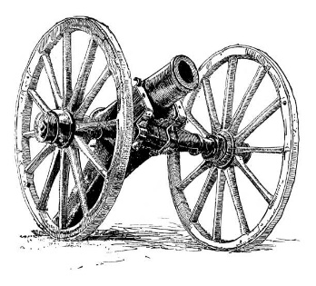
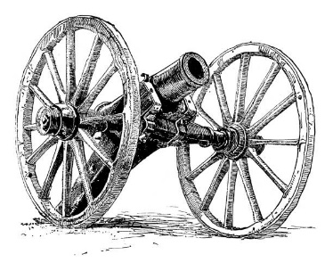
The Growler
The Newsletter of the
Cascade Civil War Society
November 2022

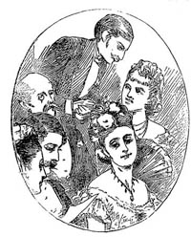
Civil War Etiquette
For our 19th century forbearers, correctly followed social etiquette, frequently referred to as "correct social intercourse", was highly sought after by both ladies and gentlemen of all social and economic levels. Unlike England where the barriers of aristocracy and nobility existed, one could always improve one's station in life in America. Following these rules of etiquette while in the public eye and in first person can greatly enhance your impression.

GENTLEMEN:
1. A gentlemen never smokes in the presence of ladies.
2. While escorting a female on the street, the lady always has the wall, allowing the gentleman to shelter her from splashing, dust and traffic from the street.
3. When you meet a lady who is only a slight acquaintance in the street or park, you must wait first for her acknowledging bow - then you may tip your hat to her, which is done using the hand that is farthest away from her. You must not speak to her or any other lady unless she speaks to you first.
4. If you meet a lady in the street whom you know well enough to speak to, do not stop her, but walk with her in which ever direction she is going. When you are finished speaking to her you may take your leave.
5. In going up a flight of stairs, you precede the lady, in going down, you follow.
6. A gentleman is always introduced to a lady, never the other way around. It is presumed to be an honor for the gentleman to meet her.
7. In walking with a lady, take charge of any small parcel, parasol, or book with which she may be encumbered.
8. To nod or merely touch the brim of the hat is far from courteous; the hat should be lifted from the head.
9. On meeting a friend with whom you are likely to shake hands, remove the hat with your left hand in order to leave the right hand free.
10. When introduced to a lady, never offer your hand. When introduced persons limit their recognition of each other to a bow.

LADIES:
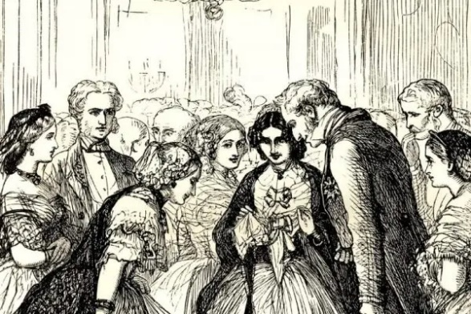
1. If unmarried and under thirty, a lady is never to be in the company of a man unchaperoned. Except for a walk to church or a park in the early morning, she may not walk alone but should always be accompanied by another lady, a man or a servant.
2. Under no circumstances may a lady call on a gentleman alone unless she is consulting that man on a professional or business matter.
3. A lady never dances more than three dances with the same partner.
4. A lady is allowed to "cut" someone - that is to fail to acknowledge their presence when encountered socially - only under extreme circumstances. An example would be a man who persists on bowing when not properly introduced.
​ 5. A lady may only be introduced to a gentleman by her father, brother, or parents' close friends.
6. A lady should never demand that a seat be given to her, whether it be in a theater, at the table or on a train, but should wait for it to be offered to her.

The Civil War Film Vault

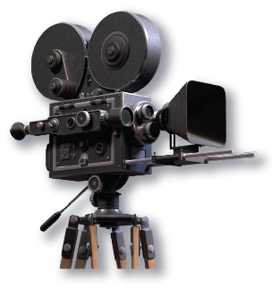
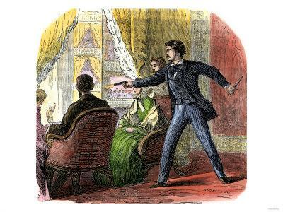
A quick look at Lincon’s Assassination
What did John Wilkes Booth hope to gain from Abraham Lincoln’s death? Here in a short video is told the thinking of Booth’s plans and his hopes for the future.
https://youtu.be/Q7KWg-HUIKs
TREATISE ON MEDICINE

PART I
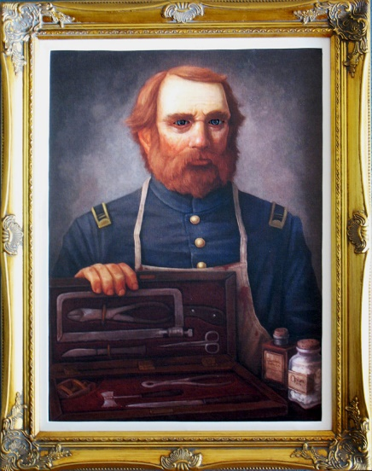
Looking back at medical science of the 1860’s brings gasps and groans of horror from
most people today. Growing up in the age of miracle drugs, antiseptics, antibiotics, and sterile
techniques; we have little or no understanding of those days before Louis Pasteur and Joseph
Lister.
We think of doctors as highly trained scientists with years and years of college and
specialized training. This has only really happened in the past two or three generations. Most
practicing physicians in 1861 had learned their profession through apprenticeship. The few
medical schools available were only 13 – 24 months in length and would admit nearly anyone
provided they were of proper age, could pay the fee and had some sort of degree. Students
spent their time in classrooms listening to boring often redundant lectures and only occasionally
examining cadavers. There was no practical experience or training; they saw no patients.
Little, if any of the breakthroughs being practiced in Europe were taught.
Most medical treatment concentrated on the regulation of the kidneys, blood and bowels.
Much time, effort, and medication was spent trying to maintain consistency of body fluids and
excretions. Massive doses of cathartics were used to regulate the bowels. Principle among
these was calomel whose high levels of mercury inevitable lead to poisoning.
Painkillers were primarily opiates; mainly laudanum (alcohol and opium) and morphine.
Anesthetics, chloroform and ether were coming into use for surgery. Though not always
readily available, they were used as much as possible particularly by the military.
Surgery, other than amputation, was still in the experimental stages and little was known
and nothing taught about infection. Pus was still often thought to be a normal part of healing.
Instruments were crude and were primarily for treatment not for diagnosing. In the entire
U.S. Army Medical Department there were only 20 thermometers and about a half a dozen
stethoscopes. Only one Confederate surgeon was known to posses a thermometer.
It was with this meager background in what, today, would be considered archaic medicine
that they headed into four years of conflict during which would be treated nearly 10,000,000
cases of injury and illness.

D.L.FOSTER 10/07

The above article first appeared in the October, 2007 Growler
Thanks to Dan Foster for resubmitting this.
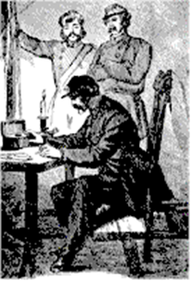
From the President’s Pen

Hello, Fellow Members,
Winter has arrived. Time to see that your rifles and pistols are clean, and that you have plenty of caps and powder for the 2023 season. If you need caps, contact Bob.
We need to work REAL HARD on recruiting. I want to see at least 5 new members in our ranks by Stewart Park, 2023! Think about it, people—if we don't start signing up new members, our wonderful club will soon fade away. And don't kid yourself. It can happen, and quickly. For an example, look at what the RACW has just lost.
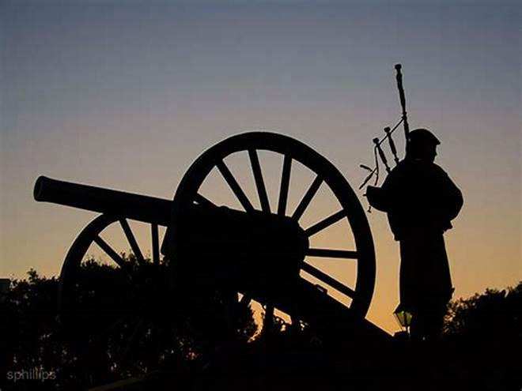
Major Don La Porta, artilleryman extraordinaire and probably the most knowledgeable artilleryman on the whole West Coast, has made the decision to retire and bring his artillery group's operations to a close. A top-quality outfit, he and his company were a force to be reckoned with for many, many years. They were incredibly well equipped, well-funded, highly trained, and possessed excellent morale, and Don himself gave our club a tremendous amount of help. So. what happened? A thing called AGE. It has a way of coming along and overtaking all of us eventually, and after several of his great soldiers passed on, and others moved away, Don was left with no crew and no one to carry on, and he reluctantly made the decision to call it quits. It is the end of an era.
Of course, Don remains a member of CCWS, and will continue to assist our artillery unit with his expertise, but his great artillery group, whose thunders shook the air in reenactments in at least three states, has passed into history.
They did great work and demonstrated Civil War artillery to thousands of people over the years. A BIG salute and many thanks to Major Don La Porta and the people who served with him! Hurrah! Hurrah! Hurrah!
1Lt. Hugh Simpson
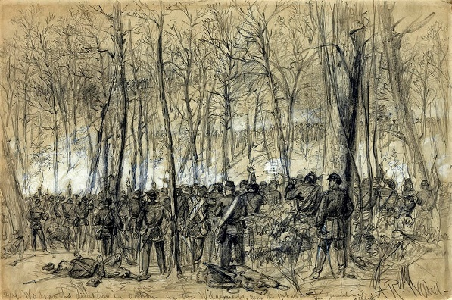
The Battle of the Wilderness
This Virginia battle was the primary clash between Ulysses S. Grant and Robert E. Lee. Confederates claimed a tactical victory. However, the North showed that they would not retreat, and Lee was forced back into the Richmond trenches.
Start date: May 05, 1864 End date: May 07, 1864

Up Coming Events
November 10th. The monthly CCWS membership meeting at the Klamath County Museum at 6:30
December 1st . NOTE THAT THE DECMBER MEETING IS ONE WEEK EARLIER THEN OTHER MONTHS OF THE YEAR. This is due to the fact the Klamath Falls “Snow Flake Festival Parade” is held on Thursday the 8th and the Museum is not available because of the parade. The monthly CCWS membership meeting at the Klamath County Museum at 6:30
December 3rd & 4th. The JSSA Gun show. (The CCWS hosts a display and recruiting table at the event. Set up is Friday the 2nd.)
December 17th. The CCWS Christmas Social at the Klamath County Museum Meeting room.
January 12th, 2023. The monthly CCWS membership meeting at the Klamath County Museum at 6:30
If you would like to submit and article or event to the Growler, please, feel free to do so. Please send it in to me at tcooley1313@gmail.com By the Saturday before the Monthly meeting (second Thursday) of each month so I can get it in the Growler

